USER MANUAL
SALES SYSTEM

SALES USER & AGENT (WAEC)

© UBT 2011
Table of Contents
Table of Contents ii
Table of Figures ii
1. Introduction 1
1.1 Login Page 1
1.2 Main Page 2
2. User Functions 3
2.1 Sales User Role 3
2.1.1 Sales Page 3
2.1.2 Sales Report Page 5
2.1.3 Change Password 5
2.1.4 Log out 5
2.2 Sales Agent Role (WAEC) 6
2.2.1 Sales Page (WAEC Agents) 6

Table of Figures
Figure 1: Login Page 1
Figure 2: Main Page 2
Figure 3: Sales Page (Agents) 3
Figure 4: Sales Page (Individuals) 4
Figure 5: Sales Report Page 5
Figure 6: Sales Page (WAEC Agents) 6

Introduction
This document is a guide for users of the Sales System which is designed for selling pins to individuals or agents.

Login Page
To access the login page, open Microsoft Internet Explorer (recommended) and type https://www.waecinternetsolution.org in the address bar.

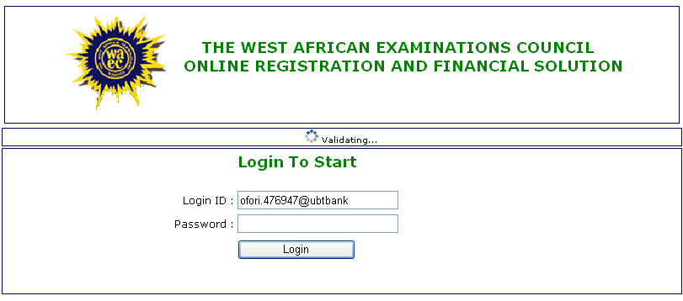
Validation of user login ID
User login ID
Login button
Password
Figure 1: Login Page

On the login page (Figure 1), enter your Login ID and Password and click on Log in.

When logging in for the first time,

- Enter the correct Login ID in the entry box and wait for confirmation.
- Enter your password in the Create New Password entry box on the new page.
- Confirm your password by re-entering your password.
- Click on Save Password to save your password.

Correct entry of the Login ID and password opens the Main page.

Main Page
This page (Figure 2) displays the menu items and the sales types. The functions that can be performed by the administrator are displayed under the menu. The visible menu items are Change Password and Logout.

Select the sales type from the sales list; REVISION PINS, RESULTS CHECKER PINS to view additional menu items.

To view or download the user manual, click on Get User Manual to open the word file format user manual.

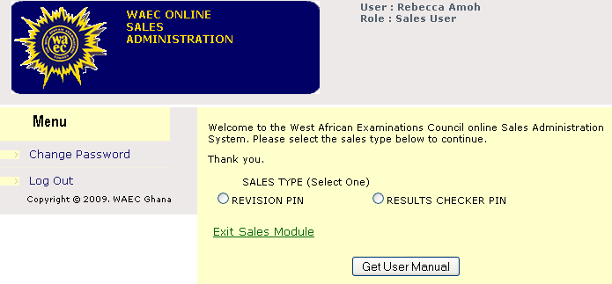
User login information
Sales types
User manual button
Menu items

Figure 2: Main Page

User Functions

Sales User Role
The following menu items are visible to the sales user after selecting the sales type;

- Sales
- Sales Report
- Change Password
- Log Out

Sales Page
This page displays a form where Sales Users enter the details for a sales transaction for either an Agent (Figure 3) or an Individual (Figure 4).

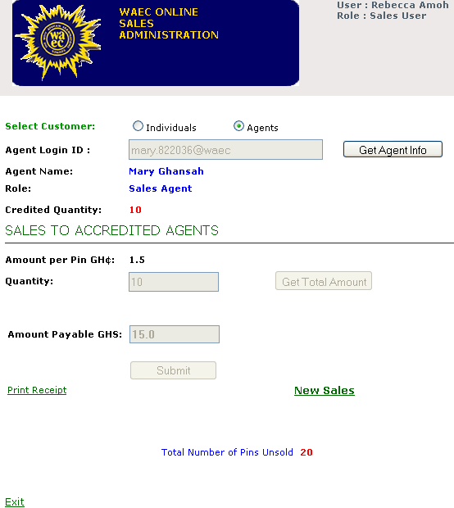
Exit
Get Total Amount Button
Select Customer
Total Amount Payable
Submit Button
New Sales
Print Receipt
Agent Information
Quantity Input Box
Get Agent Information Button

Figure 3: Sales Page (Agents)

Sale of Pins to Agents

To sell pins to Agents;

- Click Agents to select the customer type.
- Enter the Agent Login ID into the input box.
- Click on Get Agent Info to display the Agent’s information.
- Enter the Quantity of pins to be sold into the quantity input box.
- Click on Get Total Amount to display the total amount payable.
- Click on Submit after receiving the exact amount from the Agent.
- Click on Print Receipt to print the receipt for the Agent.
- Click on Exit to return to the Main page or New Sales to begin a new transaction.

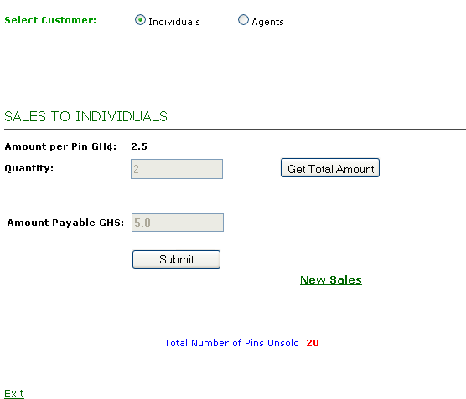
Exit
Get Total Amount Button
Total Amount Payable
Submit Button
New Sales
Quantity Input Box
Select Customer (Individual)

Figure 4: Sales Page (Individuals)

Sale of Pins to Individuals

To sell pins to Individuals;

- Click Individuals to select the customer type.
- Enter the Quantity of pins to be sold into the quantity input box.
- Click on Get Total Amount to display the total amount payable.
- Click on Submit to view the receipt after receiving the exact amount from the Individual.
- Click on Print Receipt to print the receipt for the Individual.
- Click on Exit to return to the Main page or New Sales to begin a new transaction on the Sales Page.

Sales Report Page
This page (Figure 5) displays a report on all the sales transaction for a given period. The report contains details of pins sold to individuals and agents and a summary of the total amount sold for that given period.

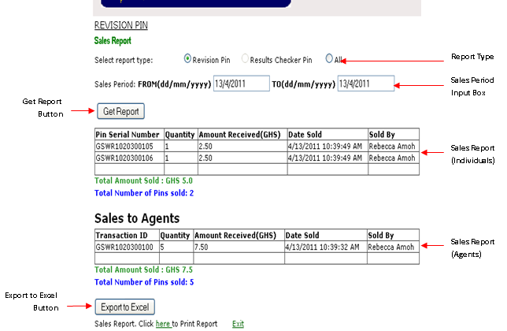

Figure 5: Sales Report Page

To view the Sales report;

- Select the report type; Revision Pin, Result Checker Pin or All.
- Enter the Sales Period in the date box in the format month-day-year (mm/ dd/ yyyy).
- Click on Get Report to view the sales transactions within the entered period.
- Click on Here to print the report
- Click Exit to return to the Main page.

Change Password
Click on Change Password under the Menu list to open the Change password Page.
Enter the old password (current) and your new password into the appropriate field and click on Change Password.

Log out
Click on Log out to exit the system.
This brings you back to default Log in Page of the Online Registration and Financial Solution.

Sales Agent Role (WAEC)
The sales agent of WAEC can see only the sales page.

Sales Page (WAEC Agents)
This page (Figure 6) displays a form where you enter the details for a sales transaction for only Individuals.

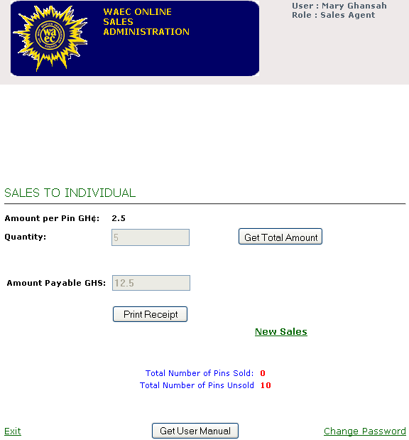
Exit
Quantity Input Box
Change password
Summary Report
Submit or Print Receipt Button
Total amount payable
Get Total Amount Button
Agent Information
User Manual Button

Figure 6: Sales Page (WAEC Agents)

To sell pins to Individuals;

- Enter the Quantity of pins to be sold into the quantity input box.
- Click on Get Total Amount to display the total amount payable.
- Click on Submit to view the receipt after receiving the exact amount from the Individual or click on Print Receipt to copy the receipt to PDF if the pins are more than one (1).
- Click on Exit to exit the system or New Sales to begin a new transaction on the Sales Page.

